Lesson 1

Starter Activity Worksheet

Micro Controllers

Lesson 1 Starter Activity

A microcontroller is an integrated circuit. Microcontrollers have programmable input/outputs, built-in memory, and a processor. They are small computers designed to perform a specific task in an embedded system.

Below is an Alexa smart home assistant, it’s an example of an embedded system. It has many inputs and outputs such as sensors and LED’s. The microcontroller or embedded system within the smart home assistant processes the inputs to determine the appropriate actions need to be taken. Can you identify any of the device inputs and outputs.

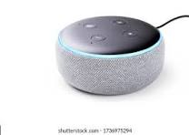

**An example has been given to get you started.**

| Inputs | Outputs |
| --- | --- |
| Microphone button | LED to show device is on |
|  |  |
|  |  |
|  |  |
|  |  |